

PRACTICAL MANUAL

Control System Lab

EXPERIMENT NO. 9

To study characteristics of positional error detector by angular displacement of two servo potentiometers.

**EXPERIMENT: 9**

**Object: -** To study characteristics of positional error detector by angular displacement of two servo potentiometers.

# APPARATUS REQUIRED: -

1. Experimental kit.
2. Dual Trace CRO.

# THEORY: -

The potentiometers are electromechanical devices contains reluctance and a wiper arrangement for variation in resistance due to displacement. Generally, all potentiometers have three terminals. The reference dc or ac is applied to fixed ends and the variable is taken from wiper terminals. When the position of wiper is shifted to other position a prepositional change in voltage occurs as the O/P voltage

e (t)=Keθ (t)

Where Ke is the proportionality constant

Which is equal to reference applied V / Angular span (rad)max and θ(t) is the shaft positions. The potentiometer error detector consists of two identical potentiometers electrically connected in parallel and supplied by a voltage source.

Assume R1 as reference shaft and kept at θ1 and O/P voltage taken as reference V1, than the R2 voltage taken from wiper will be V2 .The O/P compared between two wiper may expressed as: -

**V1 – V2 = e (t) = Ke θ1 (t) – θ2 (t) = Ke θe(t)**

e (t) is known as error voltage.

For ac excitation signal system is same .The I/P ac signal which is pronounced as carrier may be represented as

V(t) = Vsin ωct, Where θe is the angular error between reference and control potentiometer. It may be observed that θe changes its sign when there is 1800 phase shift occurs in e(t) as sinusoidal error.

**θe (t) = sin ωst**

There error e(t) may be represented as,

**e(t) = 1/2 KsV [cos(ωc - ωs)t]**

When this signal is fed through a balanced demodulator it produce a phase sensitive signal, which can be applied to controlled variable (motor).

**PROCEDURE: - (a) Excite potentiometers with D.C. signal**

Sockets at Pot – 1, and Pot – 2, wiper are provided to connect external DVM.

1. Switch on the power. Select excitation switch to DC.
2. Keep pot – 1, to center of its travel i.e. 180o = 1.
3. Connect provided DVM with the error output.
4. Turn pot – 2, from 20o to 340p in regular steps, say 20o interval and note the displacement in 2 and output voltage e, as Vo.
5. Tabulate the observations. Plot graph between Vo and  2, for straight-line approximation.

Calculate the slope of the line as,

Slope of the line Ko = Vo / e ---------- in V/o

6 Repeat above steps keeping pot–2 at fixed degree and move pot– 1.

**(b) To excite the potentiometers with ac signal and to obtain phase sensitive signal from the balanced demodulator by angular displacement of either pot.**

The potentiometers are excited from built in ac sinusoidal source of fixed amplitude (carrier) and error output is then fed into balanced demodulator, which gives phase sensitive dc signal. Other apparatus required is a dual trace CRO

1. Switch on the power. Select ac from the excitation switch.
2. Connect one of the CRO input with the carrier output socket and ground socket. Adjust vertical and horizontal deflection of CRO to obtain 2.5 div amplitude with two or more traces (vertical 2V /div and horizontal 0.5 mS/div) 3. Connect other input of CRO with the error output socket.
3. Keep pot – 1, fixed at 180o.

1. Move pot – 2, to either side and observe the error output signal phase, and its amplitude.

1. Connect error output with the balanced demodulator input. Connect DVM input with the demodulator output.

1. Move pot – 2, from 20o to 340o in steps of 20o and note the displacement in o and demodulator output in volts Vdm.

1. Plot graph from the results.

# CIRCUIT DIAGRAM:-

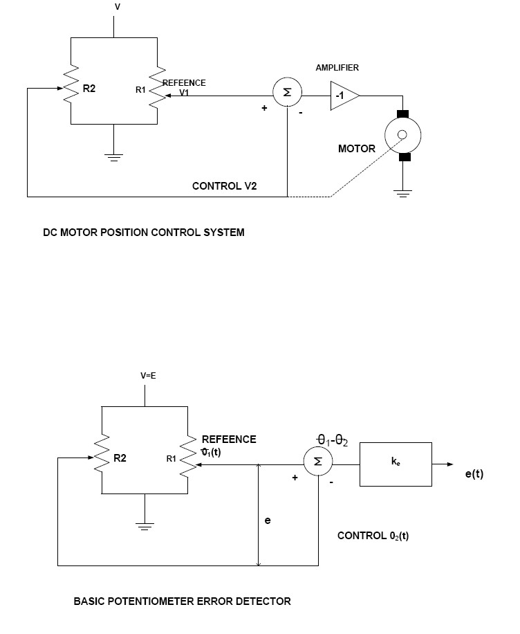

**OBSERVATION TABLE:**

# Table: 1

|  |  |  |  |
| --- | --- | --- | --- |
| Sr. No. | Pot–2 position in o | e = 1 - 2 | Output volts = Vo |
| 1  2  3  4  5  6  7  8  9  10  11  12  13  14  15  16  17 | 20  40  60  80  100  120  140  160  180  200  220  240  260  280  300  320  340 | -160  -140  -120  -100  -80  -60  -40  -20  00  +20  +40  +60  +80  +100  +120  +140  +160 |  |

# Table - 2

|  |  |  |  |
| --- | --- | --- | --- |
| Sr. No. | Pot–2 position in o | e = 1 - 2 | Inv, Output volts = Vo |
| 1  2  3  4  5  6  7  8  9  10  11  12  13  14  15  16  17 | 20  40  60  80  100  120  140  160  180  200  220  240  260  280  300  320  340 | -160  -140  -120  -100  -80  -60  -40  -20  00  +20  +40  +60  +80  +100  +120  +140  +160 |  |

**RESULTS:-**

# PRECAUTIONS: -

1. Read operating manual before working on the kit.
2. Don’t change the connection without switching off the supply of the experiment kit.
3. Draw the traces from CRO properly
4. Keep the connecting lead and ancillary equipment at proper place after completing the experiment.
5. Do not temper with the control and switches of equipment.

# VIVA VOICE QUESTIONS:-

1. State the principle of potentiometer.
2. Define sensitivity of potentiometer.
3. Define resolution of potentiometer.
4. Describe how potentiometer acts as a transducer.
5. What is the difference between displacement measured by potentiometer and LVDT?
6. On what factors, does the resolution of potentiometer depend?
7. How resolution can be increased in displacement measurement using potentiometer?
8. What are the limitations of the potentiometer?

# INDUSTRIAL APPLICATIONS:-

Potentiometers are used to control electrical devices such as volume controls on audio equipment. It is also used in a variety of rotary feedback and position indicating circuits. Potentiometers are rarely used to directly control significant power (more than a [watt)](http://en.wikipedia.org/wiki/Watt). It operated by a mechanism can be used as position [transducers,](http://en.wikipedia.org/wiki/Transducer) for example, in a [joystick.](http://en.wikipedia.org/wiki/Joystick)